Exercises HTML3

1. Imagine that you have been given this wireframe

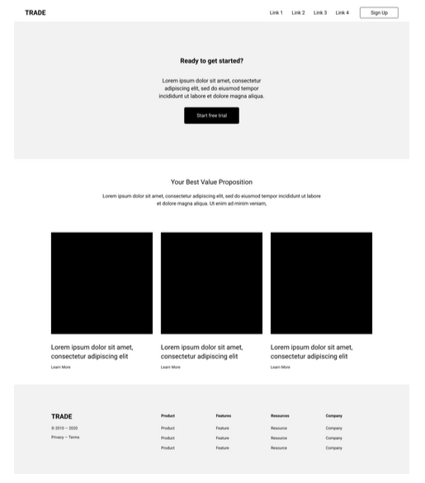
Create a HTML structure for it. It won’t look like it withouth CSS, but don’t worry, you only have to do the semantic structure in html5.

